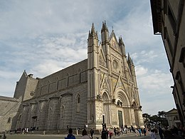**Orvieto**

I mentioned some trips you can take between one swim in the pool and the following one.

I begin by suggesting a visit to the Cathedral of Orvieto. From Montemoro Orvieto it is 18 Km away. You can leave your car in the parking lot located at the base of the cliff and go up using the escalator that is carved out of the tufa rock. If you go during the day, I recommend that you visit the interior of the cathedral relying on the guide who may also speak German, but certainly English. Do not miss the visit to the chapel of San Brizio with the paintings by Luca Signorelli. 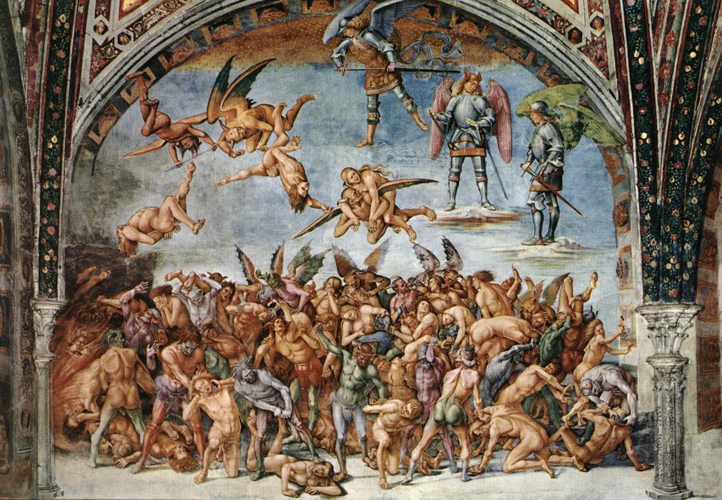

The scenes of the damned are reminiscent of Dante's hell.

If you plan to go in the evening, the view of the illuminated facade is, in my opinion, one of the most beautiful in the world. You can stop for a pizza in the many restaurants and pizzerias you will encounter along the streets.

During the day the tourist office is open where you can also book other visits: that to the Well of San Patrizio (project by Michelangelo) and to Orvieto underground, the caves dug by the Etruscans and previous populations starting from 3000 BC.